- Student Registration — Instance Variables Question: Create three students with different names and roll numbers using a method,
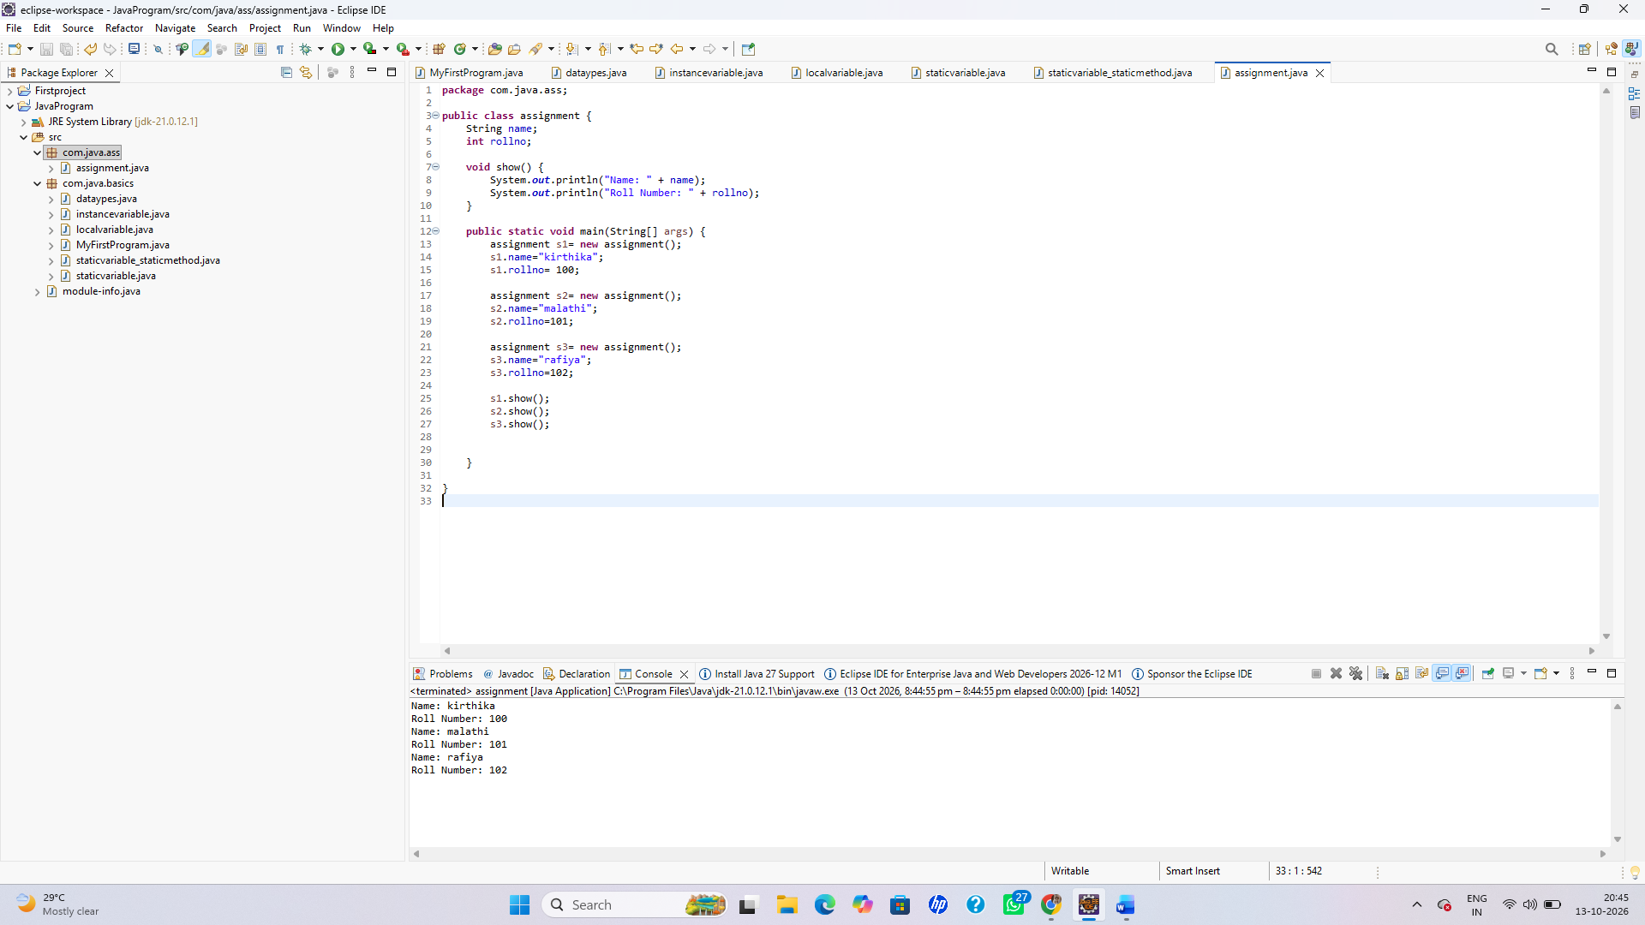
2. Employee Counter — Static Variable
Question: Count how many employee objects are created by calling a method to register each employee
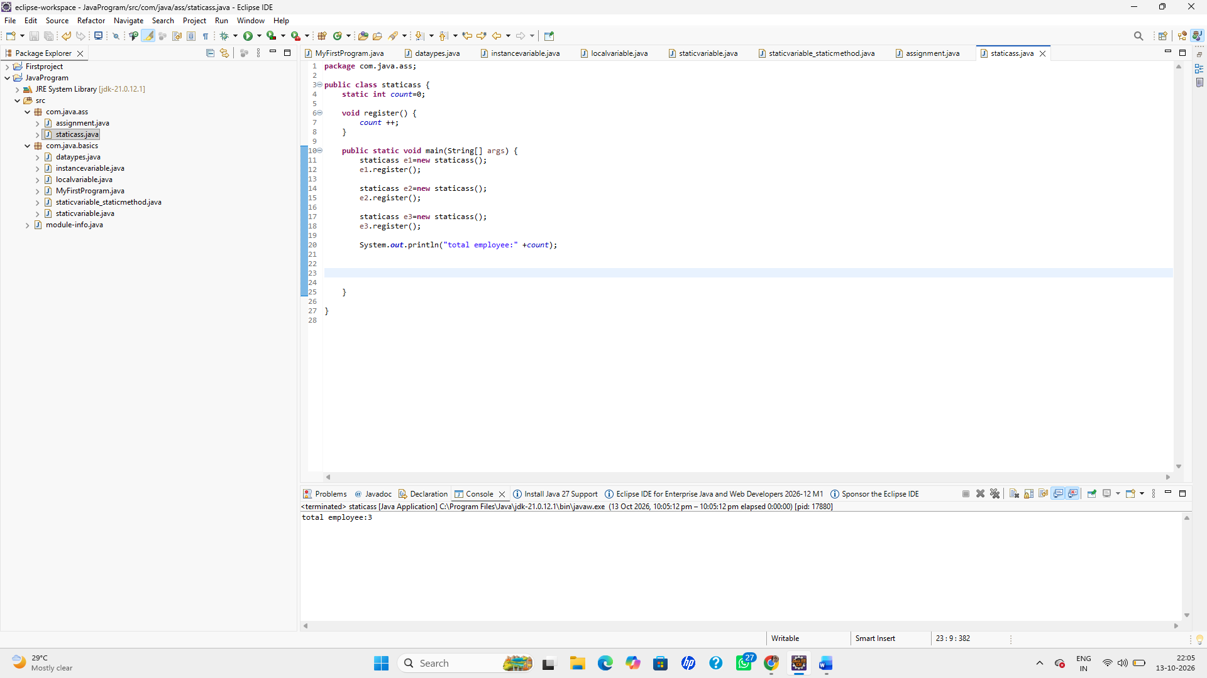
3.Electricity Bill — Local Variables
Question: Calculate the electricity bill using a method and local variables. Rates: first 100 units ₹2/unit, next 100 units ₹3/unit, and above 200 units ₹5/unit.
